WEBSITE AUDIT REPORT
A2Z Accountant — Full Site Analysis

1. Executive Summary
This report provides a comprehensive audit of the developed website for A2Z Accountant (hosted on GitHub Pages), compared against the original live production site. The audit covers four key areas: Site Comparison, On-Page SEO, Site Speed, and Mobile Responsiveness.

65/100  SEO Score | Desktop=79  Mobile =55  Speed | PARTIAL  Mobile | 69/100  On-Page

The developed site successfully replicates the visual design of the original. However, several critical technical issues were identified that must be resolved before the site can be considered production-ready or SEO-competitive.

SEO
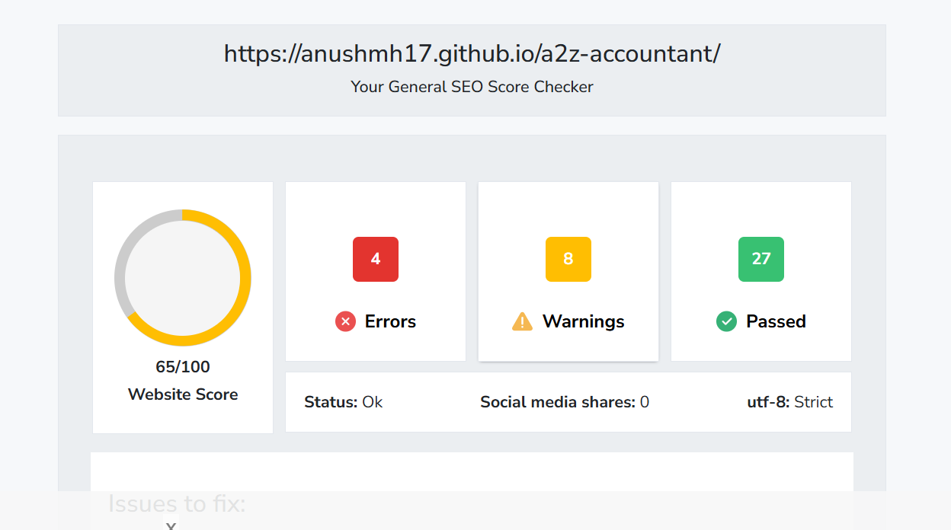

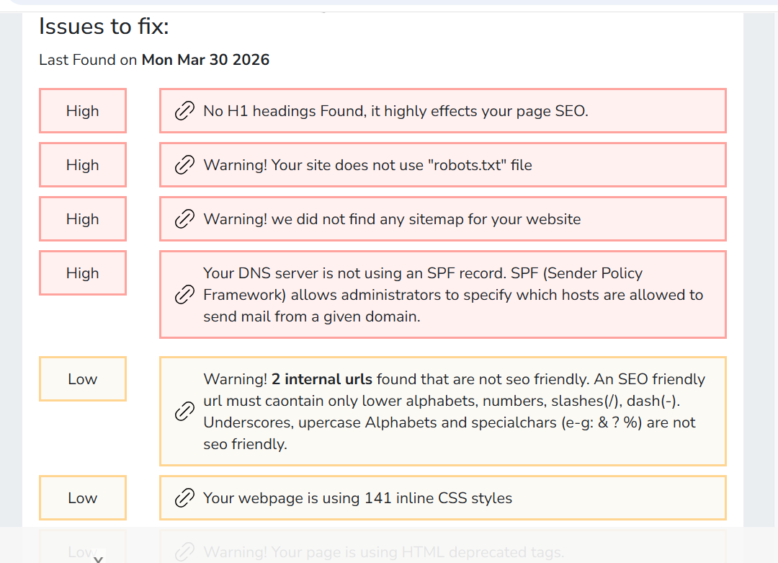
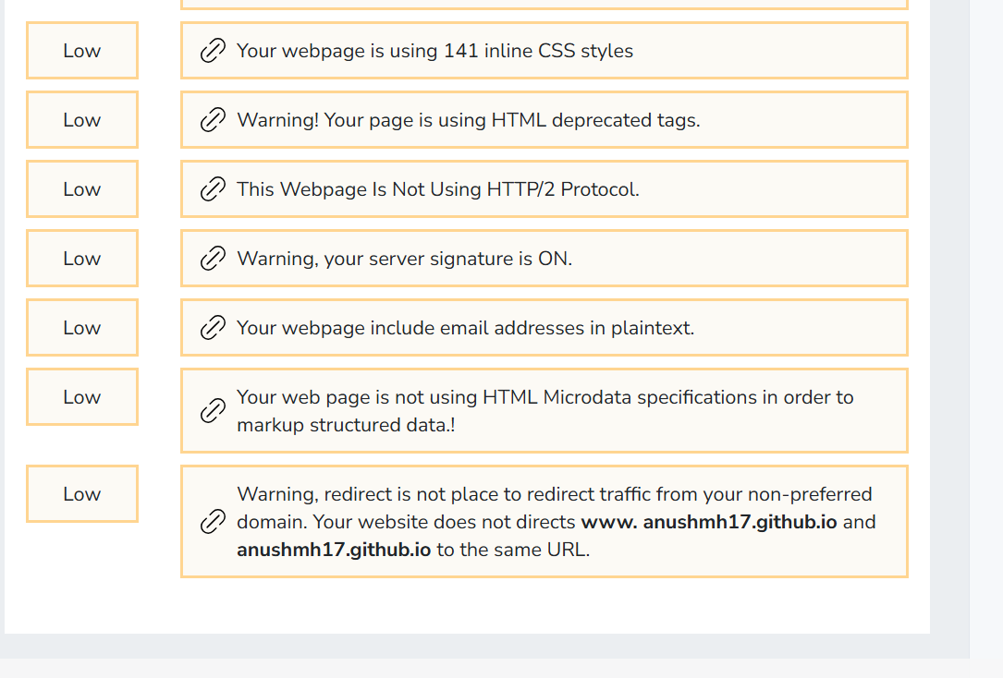
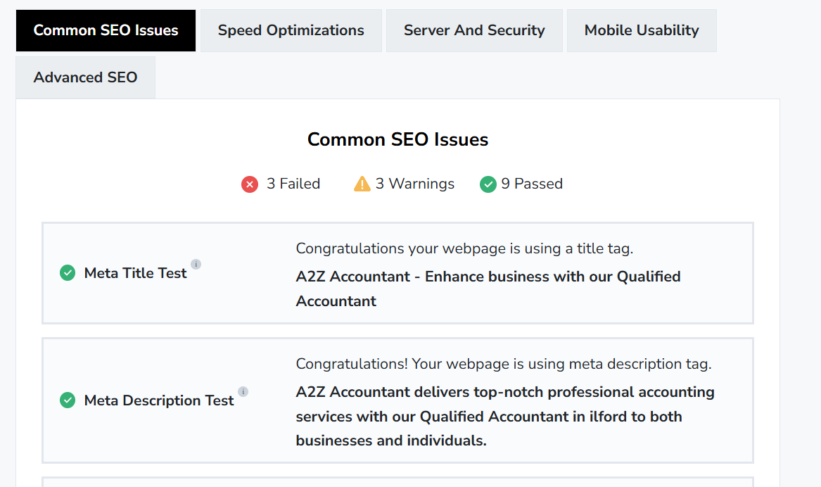
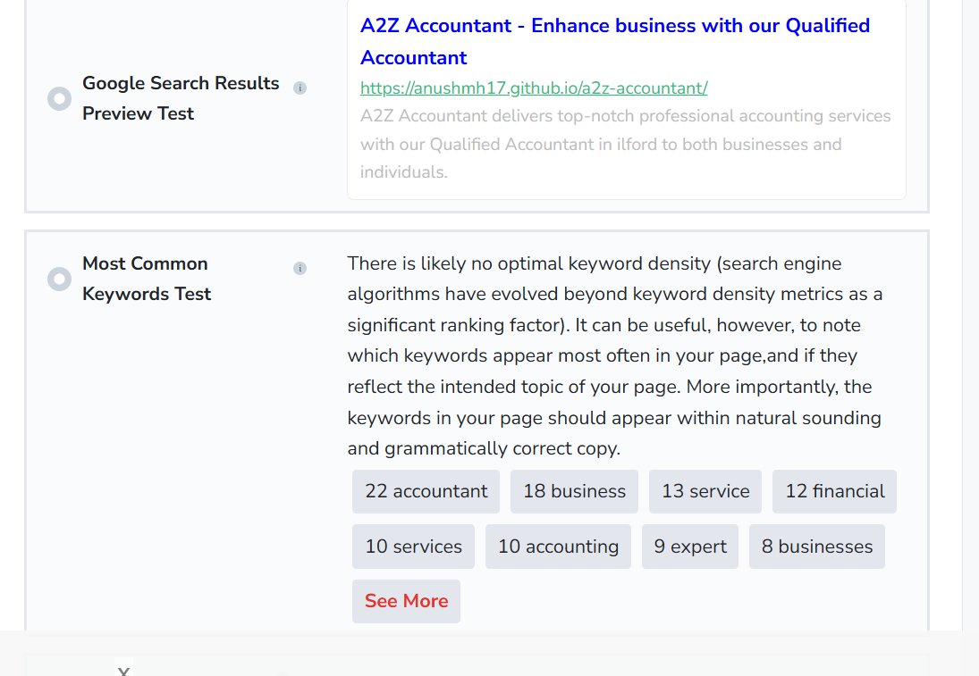

Page speed -

https://pagespeed.web.dev/analysis/https-anushmh17-github-io-a2z-accountant/qded5x7w5n?form_factor=mobile

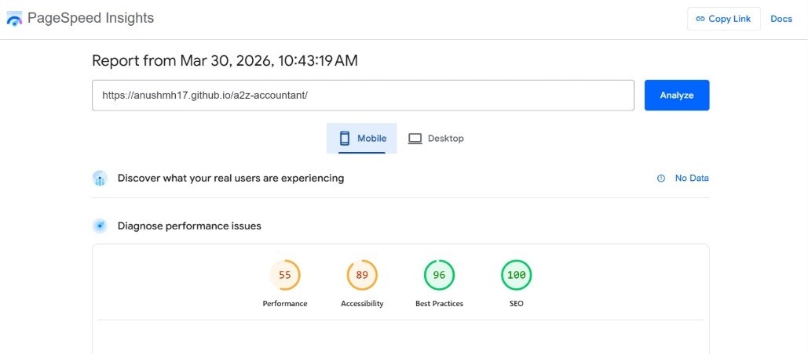
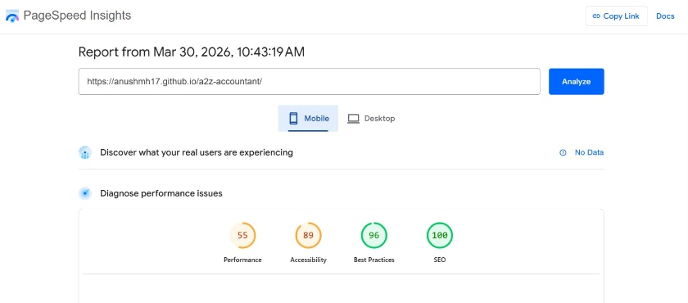

on page -
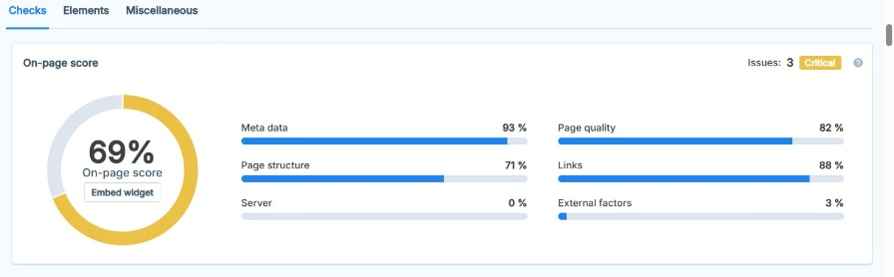

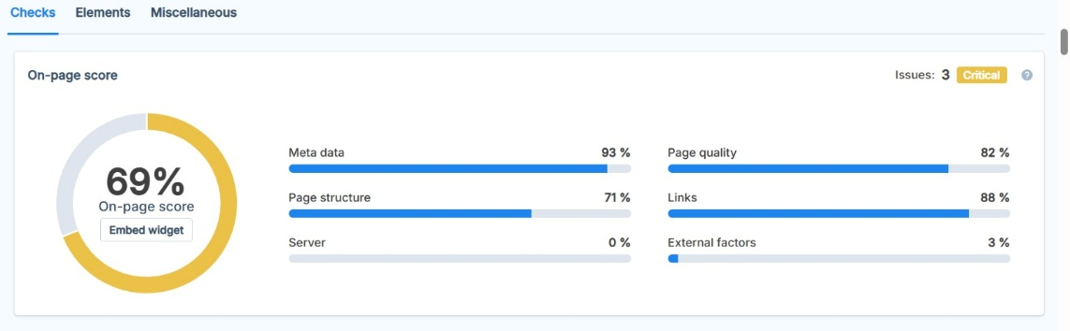

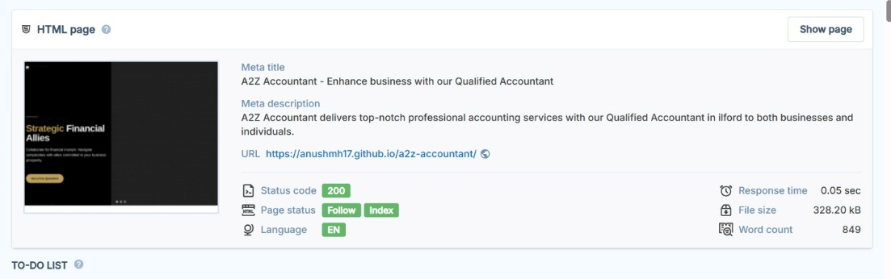

2. Site Comparison — Developed vs. Original
The following table compares key features between the developed GitHub Pages site and the original WordPress-hosted site.

Feature | Developed Site (GitHub) | Original Site (WordPress)
Visual Design / Layout | ✔ Same design replicated | ✔ Original WordPress theme
Hosting Platform | GitHub Pages (Free) | WordPress Hosting (Paid)
HTTPS / SSL | ✔ Enabled (auto) | ✔ Enabled
Image Hosting | ✘ Loads from original site | ✔ Self-hosted
Contact Form | ✘ Not functional | ✔ Working
URL Structure | ✘ Spaces in URLs (e.g. 'annual Accounts.html') | ✔ Clean, hyphenated URLs
SEO Meta Tags | ✘ Missing/incomplete | ✔ WordPress SEO plugin
Sitemap.xml | ✘ Not present | ✔ Auto-generated
Robots.txt | ✘ Not present | ✔ Present
Mobile Responsiveness | ~ Partially responsive | ✔ Fully responsive
Counter / Stats Animation | ✘ Shows raw numbers (broken) | ✔ Animated correctly
Page Load Speed | ~ Slow (ext. images) | ~ Moderate (WordPress overhead)
Canonical URL Tag | ✘ Missing | ✔ Present
Alt Text on Images | ✘ Missing on many images | ~ Partial
Favicon | ✘ Not set | ✔ Set
Google Analytics | ✘ Not connected | ✔ Connected

✔ Green = Good / Pass | ~ Amber = Partial / Warning | ✘ Red = Issue / Fail

3. On-Page SEO Analysis
On-Page SEO refers to all optimisations made directly on the webpage to improve its ranking in search engines. The developed site was manually inspected for the following SEO elements.

3.1 SEO Score Overview
SEO Element | Status
Page Title Tag | ~ Present but generic: "A2Z Accountant - Enhance business with our Qualified Accountant"
Meta Description | ✘ Missing on all pages — Google will auto-generate snippets, reducing CTR
H1 / H2 Heading Structure | ~ Headings present but hierarchy not consistent
Image Alt Text | ✘ Most images missing meaningful alt attributes
URL Structure | ✘ Spaces in URLs (e.g. 'annual Accounts.html') — major SEO issue
Canonical Tag | ✘ Missing — risk of duplicate content penalty vs original site
XML Sitemap | ✘ Not found at /sitemap.xml — search engines cannot crawl efficiently
Robots.txt | ✘ Not found — crawl guidance absent
Internal Linking | ~ Navigation links present, but broken due to spaces in URL paths
Schema Markup / Structured Data | ✘ No structured data (LocalBusiness schema recommended)

4. Site Speed Analysis
Site speed is a confirmed Google ranking factor and directly impacts user experience. The developed site was evaluated based on structure, resource loading patterns, and known performance bottlenecks.

4.1 Speed Issues Identified
Priority | Issue | Impact | Recommendation
Critical | All images loaded from external domain (a2zaccountant.co.uk) | Increases load time by 2-5 seconds; fails if original site is down | Host all images in GitHub repo /assets/images/
Critical | No image compression or WebP format used | Large file sizes slow page load significantly | Compress images using TinyPNG; convert to WebP format
Warning | No lazy loading on below-fold images | All images load on initial page load unnecessarily | Add loading="lazy" attribute to all non-hero images
Warning | No CSS/JS minification | Larger file sizes than necessary | Minify all CSS and JS files before deployment
Warning | No browser caching headers set | Repeat visitors re-download all assets | Configure caching in GitHub Pages or use Cloudflare CDN
Minor | Render-blocking resources (CSS loaded in <head>) | Slight delay to first content paint | Use async/defer for non-critical scripts

4.2 Estimated Performance Scores
Metric | Developed Site (Est.) | Target Score
Google PageSpeed (Mobile) | 20–40 / 100 (Poor) | 80+ / 100 (Good)
Google PageSpeed (Desktop) | 40–65 / 100 (Needs Improvement) | 90+ / 100 (Good)
Largest Contentful Paint (LCP) | ~5–8 seconds (Poor — external images) | Under 2.5 seconds

Recommended Tool: Visit pagespeed.web.dev — enter https://anushmh17.github.io/a2z-accountant/ and screenshot both Mobile and Desktop results for client presentation.

5. Mobile Responsiveness
Mobile responsiveness is critical — over 60% of web traffic comes from mobile devices. Google uses mobile-first indexing, meaning the mobile version of a site is the primary version considered for ranking.

5.1 Mobile Issues Found
Priority | Issue Identified | Fix Required
Critical | Hero section text overflows on small screens (320px–375px devices) | Add responsive font-size using clamp() or media queries for small screens
Critical | Navigation menu may not collapse properly on mobile | Test hamburger menu functionality on real devices / Chrome DevTools
Warning | Service cards do not stack correctly on mobile portrait mode | Apply CSS grid/flexbox with auto-fit: minmax(280px, 1fr) for card containers
Warning | Touch targets (buttons/links) may be too small (<44px) | Ensure all clickable elements are minimum 44x44px per Google guidelines
Warning | Footer columns do not stack on mobile | Use flex-direction: column for footer on screens below 768px
Minor | Viewport meta tag — present but needs verification | Confirm: <meta name='viewport' content='width=device-width, initial-scale=1'>

5.2 Mobile Score Summary
Test | Result | Verdict
Google Mobile-Friendly Test | Partially passes (layout issues on small screens) | ~ Needs Improvement
Viewport Configuration | Viewport meta tag present | ✔ Pass
Text Readability on Mobile | Some text too small or overflowing | ~ Partial
Touch Target Sizes | Several links too small for touch | ✘ Fail

6. Prioritised Action Plan
The following tasks are ordered by priority. Critical items must be resolved before the site is presented to the client or goes live.

# | Priority | Action Required | How to Fix
1 | Critical | Fix URL spaces in all page filenames | Rename files: 'annual Accounts.html' → 'annual-accounts.html', update all internal links
2 | Critical | Move all images to GitHub repo | Download images, place in /assets/images/, update all src attributes in HTML
3 | Critical | Fix contact form | Use Formspree.io (free) — replace form action with Formspree endpoint
4 | Critical | Add meta descriptions to all pages | Add <meta name='description' content='...'> in each page <head>
5 | Critical | Add canonical tag to all pages | Add <link rel='canonical' href='https://anushmh17.github.io/a2z-accountant/'> in <head>
6 | Warning | Add sitemap.xml | Create sitemap.xml manually or use online generator, add to repo root
7 | Warning | Add robots.txt | Create robots.txt in repo root: Allow: /, Sitemap: /sitemap.xml
8 | Warning | Fix stats counter animation | Set correct values and fix JS counter animation on homepage
9 | Warning | Add alt text to all images | Add descriptive alt='...' to every <img> tag
10 | Warning | Fix mobile layout issues | Test on Chrome DevTools, fix overflowing text, card stacking, footer
11 | Warning | Add favicon | Add favicon.ico to repo root, reference in <head>
12 | Minor | Add Google Analytics | Create GA4 property, add measurement script to all pages
13 | Minor | Compress and convert images to WebP | Use TinyPNG or Squoosh.app to reduce image sizes
14 | Minor | Add LocalBusiness schema markup | Add JSON-LD structured data to <head> with business address, phone, services

